Chapter 9, Solution 7.

If f() = cos + j sin,

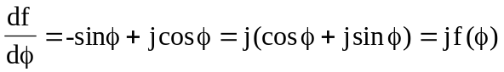

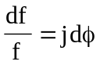

Integrating both sides

ln f = j + ln A

f = Ae^{j} = cos + j sin

f(0) = A = 1

i.e. f() = e^{j} = cos + j sin

